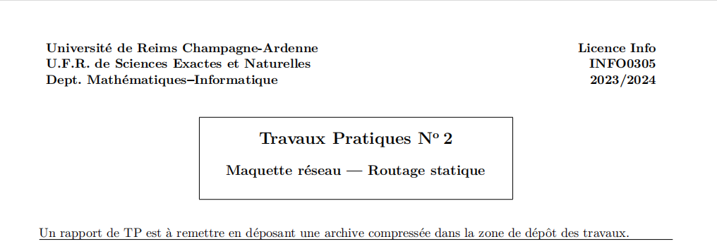

Table des matières

Niveau1 1

Niveau1 2

Niveau1 3

Niveau1 4

Niveau1 5

Niveau1 6

## Exercice 1 : 172.16.92.0

|  |  |  |  |  |  |  |  |  |  |
| --- | --- | --- | --- | --- | --- | --- | --- | --- | --- |
| I:0 | 0 | 0 | 0 | 0 | 0 | 0 | X | X | X |
| J:8 | 0 | 0 | 0 | 0 | 0 | 1 | X | X | X |
| K:16 | 0 | 0 | 0 | 0 | 1 | X | X | X | X |
| F:32 | 0 | 0 | 0 | 1 | 0 | X | X | X | X |
| G:48 | 0 | 0 | 0 | 1 | 1 | X | X | X | X |
| H:64 | 0 | 0 | 1 | 0 | X | X | X | X | X |
| L:96 | 0 | 0 | 1 | 1 | X | X | X | X | X |
| B:128 | 0 | 1 | 0 | 0 | X | X | X | X | X |
| C:160 | 0 | 1 | 0 | 1 | X | X | X | X | X |
| D:192 | 0 | 1 | 1 | 0 | X | X | X | X | X |
| E:224 | 0 | 1 | 1 | 1 | X | X | X | X | X |
| A:93.0 | 1 | x | x | x | X | X | X | X | X |

|  |  |  |  |  |  |  |
| --- | --- | --- | --- | --- | --- | --- |
|  | Adresse  Réseau | Masque  Réseau | Adresse  Brodcast | Nombre de machines | Première  Machine | Dernière  Machine |
| A | 172.16.93.0 | 255.255.255.0/24 | 172.16.93.255 | 253 | 172.16.93.1 | 172.16.93.254 |
| E | 172.16.92.224 | 255.255.255.240/28 | 172.16.92.255 | 29 | 172.16.92.225 | 172.16.92.254 |
| D | 172.16.92.192 | 255.255.255.240/28 | 172.16.92.223 | 29 | 172.16.92.193 | 172.16.92.222 |
| C | 172.16.92.160 | 255.255.255.240/28 | 172.16.92.191 | 29 | 172.16.92.161 | 172.16.92.190 |
| B | 172.16.92.128 | 255.255.255.240/28 | 172.16.92.159 | 29 | 172.16.92.129 | 172.16.92.158 |
| L | 172.16.92.96 | 255.255.255.240/28 | 172.16.92.127 | 29 | 172.16.92.97 | 172.16.92.126 |
| H | 172.16.92.64 | 255.255.255.240/28 | 172.16.92.95 | 29 | 172.16.92.65 | 172.16.92.94 |
| G | 172.16.92.48 | 255.255.255.240/28 | 172.16.92.63 | 13 | 172.16.92.49 | 172.16.92.62 |
| F | 172.16.92.32 | 255.255.255.240/28 | 172.16.92.47 | 13 | 172.16.92.33 | 172.16.92.46 |
| K | 172.16.92.16 | 255.255.255.240/28 | 172.16.92.31 | 13 | 172.16.92.17 | 172.16.92.30 |
| J | 172.16.92.8 | 255.255.255.248/29 | 172.16.92.15 | 5 | 172.16.92.9 | 172.16.92.14 |
| I | 172.16.92.0 | 255.255.255.248/29 | 172.16.92.7 | 5 | 172.16.92.1 | 172.16.92.6 |

|  |  |  |  |  |  |
| --- | --- | --- | --- | --- | --- |
|  | Interface |  |  |  |  |
| R1(A/B/C/D/E) |  |  |  |  |  |
| R2(A---H) |  |  |  |  |  |
| R3(H--F/G) |  |  |  |  |  |
| R4(H--kl) |  |  |  |  |  |
| R5(K--I/J) |  |  |  |  |  |

